Jun27 Trading

Monday

It was an all up day. First 10 signified the rest of the day. All first 5 was up, signifying a willingness to buy.

Put in more effort in the pattern of first 10 in determining the strength.

**Tuesday, June 28, 2016**

Shorted this morning due to yesterday's strong session. Markets were however much stronger than expected, so lost money today.

First five was down but first 10 was up. Pay attention when there are discrepancies between the first moves.

**Wednesday, June 29, 2016**

Europe and US massively rebounded.

When you trade, don't do it out of hurry.

Morning strategy is still uncertain. AM trading is not yielding any profits.

PMCL is the key profit generator.

Big position when the previous day is negative, small long when previous day positive.

More clear rules need to be sought out.

How to combine current knowledge into a trading strategy is the key.

Short position continues to bleed. Today is the third day market closes at the high. After the Brexit vote, markets rallied 2%. This can be seen as the alleviation of the uncertainty as well as Yellen delaying her rate hike. Markets broke the recent trading range. Even after market, the strength ensues at the highs of the day.

Positioning is shifting towards the bullish side.

Down about 160 on this position.

Thursday, June 30, 2016

Down about -230 from the position.

Markets are still in a retaliation relief rally mode.

China didn't lose much on the first day (Friday) and it rallied hard alongside the global markets on the following days ( Mon – Wed).

Did not trade on Monday and shorted on Tuesday, underestimated the strength of the rebound on the US and European side.

Lesson going forward: key strategy is pm trading (pmcl trading). Don't trade during the AM.

1. Shorting has a low Sharpe and is a gamble
2. stick with the strategies with high Sharpe.
3. Stick to first principles

First 10 is up, very strong. However, retPMCO is negative for

weekday retPMCOYCat amFirst10Cat mean cum max min sd ud dd sr sortino

13: 4 (0.0058,0.0837] [-0.0364,-0.00209] -0.0052 0.6986 0.0261 -0.0396 0.0128 0.0064 0.0103 -6.4343 -7.9806

14: 4 (0.0058,0.0837] (-0.00209,-7.8e-06] -0.0030 0.8466 0.0277 -0.0426 0.0117 0.0065 0.0116 -4.0129 -4.0289

15: 4 (0.0058,0.0837] (-7.8e-06,0.00214] -0.0008 0.9594 0.0139 -0.0267 0.0089 0.0044 0.0078 -1.4411 -1.6429

16: 4 (0.0058,0.0837] (0.00214,0.0312] -0.0026 0.8961 0.0153 -0.0362 0.0101 0.0050 0.0079 -4.1131 -5.2498

With percentileYCat:

13: 4 (0.906,1] [-0.0364,-0.00209] -0.0045 0.7416 0.0168 -0.0396 0.0120 0.0049 0.0114 -5.9573 -6.2904

14: 4 (0.906,1] (-0.00209,-7.8e-06] -0.0027 0.8390 0.0112 -0.0421 0.0086 0.0034 0.0094 -4.9850 -4.5597

15: 4 (0.906,1] (-7.8e-06,0.00214] -0.0008 0.9603 0.0139 -0.0200 0.0066 0.0036 0.0053 -1.8444 -2.3274

16: 4 (0.906,1] (0.00214,0.0312] -0.0029 0.9000 0.0101 -0.0265 0.0088 0.0040 0.0060 -5.1861 -7.5888

Wait patiently until people's steam runs out.

Markets can remain irrational longer than you can remain solvent.

Tech bubble busted, China bubble busted as well.

MSCI rejection was forgotten quickly, Brexit didn't cause any damage. After Brexit markets straight rose for 3+ days.

Always remember that markets overreact because of people that have too much position. Due to uncertainty, people would rather lose a fixed amount of money than risking their job. On the upside,

Covered the short. Positive pmFirst10. Coupled with this morning's positive amFirst10.

The mistake was groundless trading in the AM on Tuesday.

Friday, July 01, 2016

Today marks the beginning of the second half of the year.

Weekly recap:

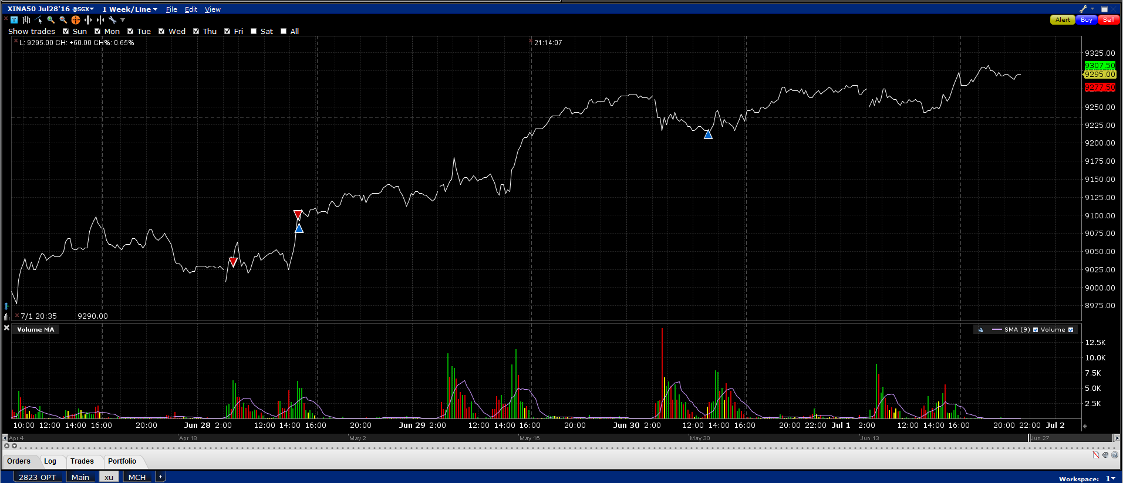

Trading is bad this week. Wednesday and Thursday was wiping after the unsmart trade on Tuesday. The shorting was done because I surmised the markets to be weak. However, peripheral markets were all going up. US had a down day on Monday and very bullish Tuesday, Wednesday, and Thursday. This weak is strong mainly because Yellen's rate hike probability is out the window following the Brexit. Overnight sessions on Tues, Wed and Thurs were exceptionally strong.

In hindsight, Monday was strong because markets China was not affected by Brexit and US is not affected by Brexit but Yellen will delay rate hike, which is what is on everyone's mind. Britain emerges as the biggest loser as it might enter into a recession but the impact on the world is small.

The week shows that market severely overreacts at the beginning and quickly corrects itself. China emerges as the winner after this rout, due to its insulation from the global markets.

Monday: Following a strong first 5, should follow. In the pm, pmFirst10 is positive which means should buy pm on the low.

Tuesday: AM first 10 was up however I don't know why I was looking at amFirst5. I was under the impression that Tuesday would be a down day due to Monday's superb percentileY. However, strength continued. From first principles, with a amFirst10>0, shorting doesn't have a good Sharpe at all.

Wednesday: Am first 10 again was positive. PM started pulling up around 14:30 which is considered to be late.

Thursday: I finally had the chance to cover the position after a loss of more than 2%. Although index closed down, Europe was still on fire, and the A50 futures continues to rally in the overnight session.

Friday:

7.2 Saturday, July 02, 2016

On Tuesday and Wednesday, the last half hour of the day is bullish and has the highest Sharpe. Focus on trading this.

Note that leverage should be applied to trading strategies where the Sharpe is the highest, not the return. Strategies with the highest Sharpe can use leverage to achieve the same return at a lower standard deviation. From the point of CAPM, the strategy with the highest sharp is the market portfolio.

When amFirst10>0,